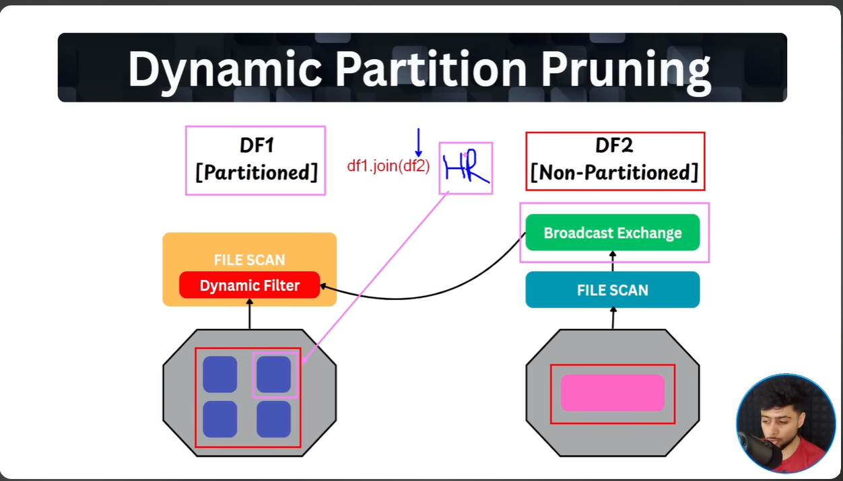
Here , the DF2 non-partition/small data will simply get forwarded/broadcasted as a filter to DF2 partitioned data so that instead of scanning everything it just smartly scans only the forwarded filter from DF1. This will be achieved with the help of below syntax :
df_join_new = df_withoutpart.join(df_withpart, (df_withoutpart['name']==df_withpart['name']) & (df_withoutpart['department']==df_withpart['department']), how='inner')
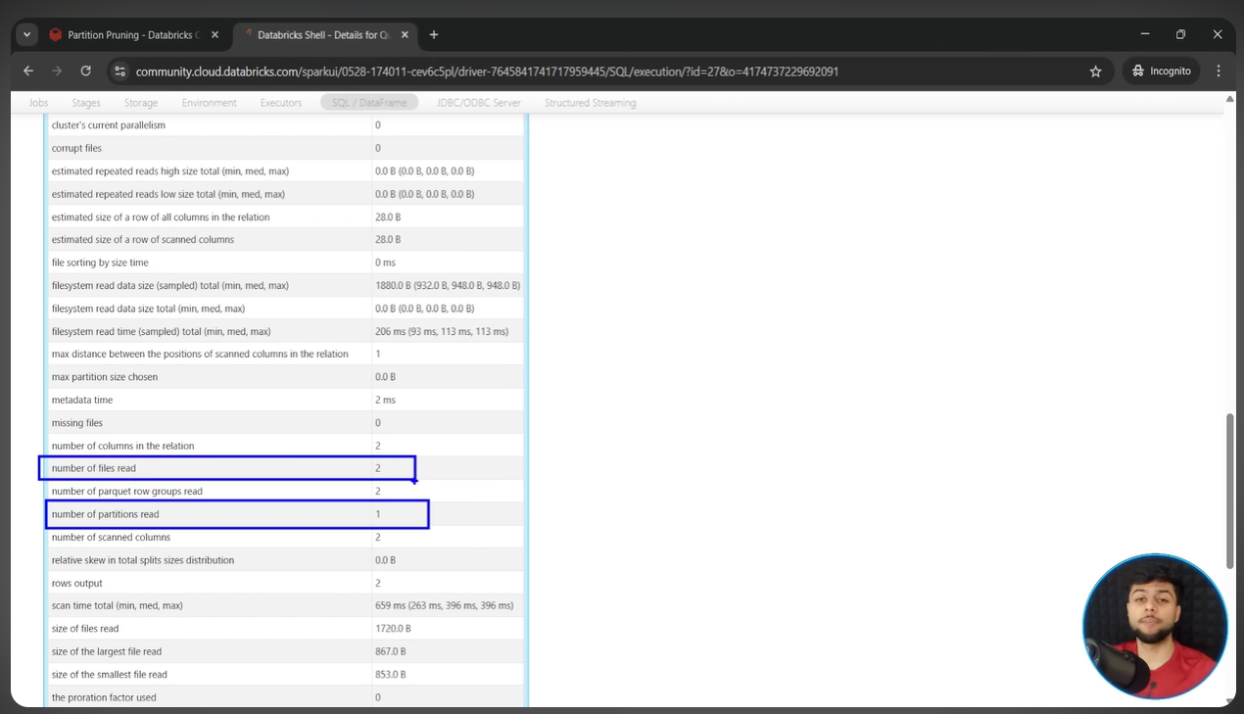
Refer 2nd last cell of https://dbc-ab1aa973-0c27.cloud.databricks.com/editor/notebooks/3213986030460209?o=4329490874745353#command/8418017044796356

